Dear adeeb ul hassan

karachi

sindh

gulshan

AS software agency

I recently heard you were hired for the Project Manager position at AS software agency. Congratulations! I’m wishing you much success and happiness in your new job. I feel I can speak for the whole team in saying that you will be deeply missed.

I have no doubt that your skills and years of experience will prove to be a major asset to your new company. Please be sure to stay in touch.

Yours truly,

Ahsan Sajjad

AS software agency

Output:

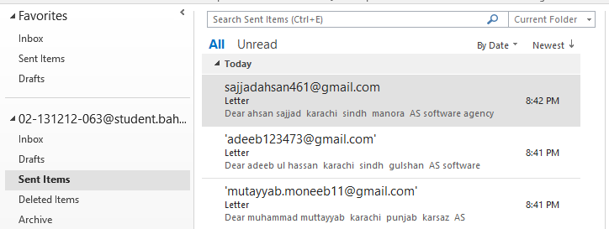

**01:**



**02:**

